Department of Humanities and Education

Pakistan Studies
Course Outline

Course: Pakistan Studies

Course Code: HU- 115 Credit Hours: 02

Undergraduate
Degree
General
Education Requireme nts
Social
Scienc es
Pakistan
Studies

Faculty of Social Sciences Air University, Islamabad

Course: Pakistan Studies
Code: HU-115
Credit Hours: 02

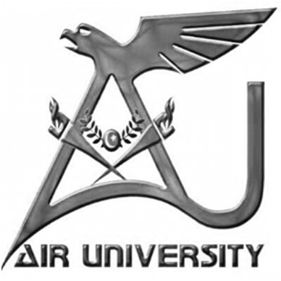

Department of Humanities and Education
Faculty of Social Sciences

Air University Islamabad

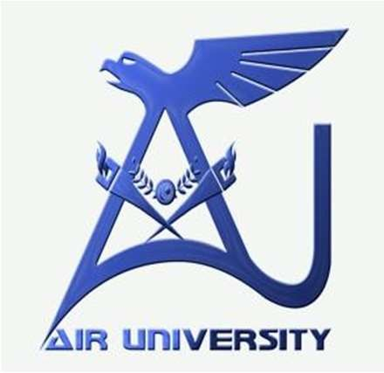
Department of Humanities and Education

Air University

COURSE SYLLABUS

Course Code: HU-115 Credit Hours: 02

Course Description:
In the light of HEC’s curriculum, the course of Pakistan Studies is designed to develop familiarity with the historical processes and perspectives on Muslim nationalism in pre-partition India, and the creation of Pakistan. The course begins with an introduction to ancient civilizations that existed in the region comprising Pakistan. It also examines Pakistani politics, society and culture. More, it discusses the objectives and principles of Pakistan’s foreign policies and analyses the challenges Pakistan has been facing in the execution of the goals of its foreign policies. The course, furthermore, looks at some contemporary issues that afflict the country. The course of Pakistan Studies aims at instilling in the minds of students a strong sense of national patriotism and pride.

Course Objectives:

- To know and understand governance structure, political processes, constitutional and legislative development, and myriad cultures of Pakistan with a sense of ownership & contribution to the country.
- To understand the ideological and historical struggle in the creation of Pakistan.
- To demonstrate the knowledge & education in practical life.
- To analyze Pakistan’s foreign policies with global and neighboring powers and familiarize students with global economic and sustainable processes and international non-state actors such as UO, UNESCO and World Bank.

Course Contents:
Week | Topics
Week1 | - An overview of Indus Valley Civilization, Gandhara Civilization, Mehrgarh Civilization  - Evolution and growth of Muslims in Subcontinent, Role and Emergence of Sufis in Islamic expansion in subcontinent.
Week 2 | - Geography of Pakistan: Landscapes, Heritage Sites, Water and Natural Resources  - Environmental Challenges and remedies: Climate Change and Global Warming
Week 3 | - Society and Culture of Pakistan: socio-cultural diversity  - Languages and Literature of Pakistan
Week 4 | - An overview of political and economic developments from 1947-1969
Week 5 | - An overview of political and economic developments from 1971-1977
Week 6 | - An overview of political and economic developments from 1977-1988  - An overview of political and economic developments from 1988-1999
Week 7 | - An overview of political and economic developments from 1999-2008  - An overview of political and economic developments from 2008- present
Week 8 | Mid Semester Exam
Week 9 | - Economy of Pakistan: Services, Manufacturing & Agriculture profile of Pakistan  - Functions and role of State institutes: Military Bureaucracy: Armed Forces, Civil Bureaucracy: FBR, PIA, Steel Mill, Railways, Postal Service etc.  - CPEC and its significance
Week 10 | - Foreign Policy: Definition, Scope, Principles, Objectives & Challenges  - Relations with neighboring countries
Week 11 | - War on Terror & role of Pakistan  - Geo-Political and Geo-Strategic significance of Pakistan in regional and Global Politics
Week 12 | - Contemporary Pakistan:  Human Rights and Social Issues  Education system
Week 13 | - Contemporary Pakistan:  Media and Social change  SDGs and Pakistan
Week 14 | Seminar Week
Week 15 | Final project / presentation
Week 16 | Final Semester Exam

Pakistan Studies Course Learning Outcomes

CLOs= Course Learning Objectives PLOs=Program Learning Objectives

S.  No. | CLO Statement | PLO | Learning Domain Level
1 | Understand the ancient civilizations that existed in the width and breath of Pakistan | PLO-6  GA-08 | C2
2 | understand geographical, historical, political, economic, and social aspects of Pakistan | PLO-6  GA-08 | C2
3 | Interpret and analyze the governance structure, political processes, economic development and myriad cultures of Pakistan. | PLO-12  GA-10 | C3
4 | Analyze the objectives and principles and challenges of Pakistan’s foreign policies, war on terror, geo-political and geo-economic significance of Pakistan | PLO-12  GA-10 | C4

PLOs and CLOs Association

Engineering Knowledge | Problem Analysis | Design/ Development of Solutions | Investigation | Modern Tool Usage | The Engineer and Society | Environment and Stability | Ethics | Individual and Team Work | Communication | Project Management | Life Long Learning

RUBRICS

Assignment:
Criteria | Quality
Criteria | Excellent | Average | Poor
- Give 3 reasons of poor  management the given topic?  - Highlight 3 repercussions of the subject matter.  - Suggest 3 remedial steps to solve the given  issues. | The assignment  will identify reasons, repercussions, and suggestions-three each- of the given topic. | The assignment will identify two reasons and two remedies as required. | The assignment will identify one reason and one remedy as required.

Quiz:
Criteria | Quality
Criteria | Excellent | Poorest (Zero marks)

Identification correct choice | of | Excellent (Student  option) | picks | correct | Poor  (Student picks incorrect option)

Project:
Criteria | Quality
Criteria | Excellent | Average | Poor
Following the benchmarks as given by the teacher concerned at the time | Student covers all portions of question in a well-versed manner in at above average level.  Or Student chooses correct option) | Student responds at satisfactory level. | Student lacks comprehension, relevance and authentic knowledge will in this category.

Reference Books:
- Sharif-ul-Mujahid. 1976. Ideological Orientation of Pakistan. Islamabad: Ministry of Education, Government of Pakistan.

- Wolpert, Stanley. 1993. Jinnah of Pakistan. Karachi: Oxford University Press.

- Habib, Irfan. 2015. The Indus Civilization. Tulika Books; Ninth Edition.

- Dhulipala, Vinkat. 2015. Creating a New Medina: State Power, Islam, and the Quest for Pakistan in Late Colonial North India. Dehli: Cambridge University Press.
- Iqbal, Muhammad. 1930. The Reconstruction of Religious Though in Islam.

- Jalal, Ayesha. 1994. The Sole Spokesman: Jinnah, the Muslim League and the Demand for Pakistan. Cambridge: Cambridge University Press.

- Saeed, b. Khalid. 1968. Pakistan: The Formative Phase (1857-1947). Oxford University Press.

- Wolf, Siegfried O. 2020. The China-Pakistan Economic Corridor of the Belt and Road Initiative Concept, Context and Assessment. Switzerland: Springer Nature.

- Rizvi, A. Hassan. 1993. Pakistan and the Geo-strategic Environment: A Study of Foreign Policy. New York: Palgrave Macmillan.
- Samad, Abdus, Governance, Economic Policy and Reform in Pakistan. Lahore: Vanguard.

- Khan, Jameel-ul-Rehman. 1999. Government and Administration in Pakistan. Islamabad: Public Administration Research Centre.

- Sattar, Abdul. 2007. Pakistan Foreign Policy 1947-2005: A Concise History. Karachi: Oxford University Press.

- Hathaway, R. M & Kugelman, M. 2009. Powering Pakistan: Meeting Pakistan’s Energy Needs in the 21st Century. Oxford University Press.
- Govt. of Pakistan. Annual Report 2017-2018: Review of Economy. State Bank of Pakistan. 2018.

- Talbot Ian. 2012. Pakistan: a new history, Karachi: Oxford University Press.

- MDGs UN https://sdgs.un.org/goals Pakistan https://www.sdgpakistan.pk/web/sdgs.

- Government of Pakistan. Classifying SDGs Targets & Indicators Technical Paper. Aug 2019.

- Government of Pakistan. National Communications Strategy. Oct, 2020.

Instructional Tools and Evaluation Methods:

The instructor will assess student's performance through several evaluation methods that include homework, class quizzes, Q/A sessions, assignments, mid-term, and final examinations.

Course Assessment and Evaluation: 100%

Class participation/ Assignments 10%
Quizzes 10%
Project/Presentation 10 %
Mid Term Examination 25%
Final Examination 45 %

REVISED BY:
Dr. Aziz Ullah Kakar
Ms. Hafsa Ali
Ms. Hadiqa Sohail
Ms. Zarafshan Tahir

Approved By:

__________________
Dr. Sadaf Zamir Ahmed
Chair Person
Department of Humanities and Education

Approved By:

________________

Prof. Dr.Wasima Shahzad
Dean of Social Sciences
Faculty of Social Sciencs

